**SOFTWARE DEVELOPMENT PROPOSAL**

**PREPARED FOR**

**Jimmy**

**PREPARED BY**

**Group 8 (Andy, Syahir, Zaki, Zell)**

| **PROJECT OVERVIEW** |
| --- |
| The purpose of this document is to provide a business solution for a medium-sized enterprise that is selling apparel with the intention to migrate from on-premise infrastructure to a cloud-based infrastructure to keep up with its current demand and put into place its regional expansion plans. |
| **PURPOSE / GOALS** |
| Our primary focus is to achieve a comprehensive transformation in migrating from an on-premises environment to a cloud environment which will address the critical problems faced by the current on-premises infrastructure. By adopting a cloud-based approach, we aim to achieve the following goals:   * Prioritise security in the wake of its major security breach on its on-premises infrastructure * Maintain performance in terms of scalability & speed to keep up with the increasing workload & provide an improved user experience respectively |

| **OBSTACLES (IF ANY)** |
| --- |
| * **Unmanageable Surge in Web Traffic:** Dealing with sudden spikes in web traffic proved overwhelming, often resulting in website crashes and performance degradation * **Security Vulnerabilities**: The presence of security loopholes resulted in instances of personal information being compromised, eroding customer trust and confidence * **Cost Intensiveness:** The significant expenses associated with establishing and maintaining on-premise infrastructure posed a substantial financial burden * **Feature Limitations:** Shortcomings included a lack of advanced capabilities such as real-time analytics, automated marketing and streamlined customer support |
| **INDUSTRY / MARKET RISK FACTORS** |
| Service Disruption   * Cloud Adoption affects business operations and customer experiences * Accurate evaluation, proof of concept and external advice are crucial. * Aim for lower-impact workloads to reduce overall risk   Time to Market/Competition   * Swiftly define and construct a Minimum Viable Product (MVP) * Longer time on the market leads to insights and product improvement * Clearly define niches for actionable feedback * Iterative process leads to significant impact   Cost Governance   * Changes in cost models require close collaboration between business and IT * Establish transparency for services consumed by different units * Utilise cost management features in the cloud (budgets, alerts, rules)   Data Loss   * Transformation introduces data breach risks * Regular data backups are proactive measures * Implement security baseline, data classification, and rationalization   Reduced Visibility and Loss of Control   * Focus on application-level monitoring and effective IAM strategies * Adopt cloud-ready security solutions and enforce clear policies * Cloud transition reduces visibility and control   Increased Workload Complexity   * Transform organizational culture with a cloud centre of excellence * Identify key skills and provide training opportunities * Seek external cloud experts for coaching * Cloud migration strains existing IT staff |
| **BUDGETARY CONSIDERATIONS** |
| For developing a comprehensive budgetary plan for cloud transition, include these factors:  Total Cost of Ownership (TCO) Evaluation   * Compare current data centre expenses (existing hardware and software assets) to public cloud usage-based billing * Consider direct(purchase, operational, maintenance, administrative) and indirect costs (include shadow IT resources and interdependencies, lost productivity due to downtime) associated with IT infrastructure.       Cloud Migration Considerations   * Assess applications for migration approach (redevelopment) * Redesign applications, set up development/testing environments. * Estimate migration timeline and Azure costs.   Determining Cloud Migration Costs   * Calculate costs based on data transfer, storage expenses, labour costs (code rewriting, DevOps) * Use cloud provider calculators for estimation * Assess Total Cost of Migration (TCM) including design, build, data transfer fees   Interim Operation Costs   * Include expenses during transition to full cloud operations * Cover service management, training, configuration, monitoring, analytics, security |
| **SYSTEM DESIGN** |
| **Diagram of System Architecture using Microsoft Azure**    **Dataflow**   1. Customer accesses the public website in the browser. 2. Browser pulls static resources and product images from Azure Content Delivery Network. 3. Content Delivery Network pulls product images from blob storage. 4. Customer searches for products. 5. Public website pulls product catalogue from product database. 6. Page output is cached in the Azure Cache for Redis. 7. Customers create new orders after authenticating against Azure Active Directory B2C. 8. Public website invokes orders web service. 9. Orders web service saves/loads orders from Azure SQL Database. 10. Employee accesses the admin website in the browser. 11. Employee authenticates against Azure AD. 12. Employee searches orders. 13. Admin website invokes orders web service.   **Components of the System Architecture**  Azure App Service   * Set up 3 distinct Web Apps: the Public website, the Content website and the Orders Admin website   + **Public website**: the customer-facing front end for browsing products and making purchases   + **Content website**: the front-end system for managing and presenting content for the e-commerce business   + **Orders Admin website**: the back-end system for order management and administration * Set up API Apps   + **Orders web service:** thesystemresponsible for order management, order processing, order tracking, integration with other components and sending notifications * The App Service plan will be as follows:   + Operating System: Linux   + Region: Southeast Asia   + Pricing tier: **Standard** **Service Plan S2** * Features to be implemented:   + Custom Domain Name: to be used for the publicly accessible web apps   + Autoscaling: to be enabled   + HTTPS: to be enabled   + TLS/SSL certificates: to create free managed TLS/SSL certificate to secure custom domains in App Service   + Deployment Slots: to use staging environments before deploying to the production environment   Azure SQL Database   * Set up 2 distinct SQL databases   + **Product Catalogue database**: Contains product information such as names, descriptions, pricing and availability status   + **Orders database**: Contains sensitive customer & financial information such as names, e-mails, addresses and credit card information * Use the **DTU-based purchasing model** for a simplified approach to resource management, easier budget planning and faster migration process   + Select the **Premium service tier** as it is designed for Online Transaction Processing applications with high transaction rates and low latency I/O requirements * Use the **single database deployment option** for its isolation and resource allocation   Azure Cache for Redis   * Cache web output allowing users to access and load the web page faster * Use the **Standard C2/C3 cache Plan**   Azure Blob Storage   * Set up a single blob storage account which will be used to store the product images for the e-commerce business * Use the **General-Purpose v2 (Standard) storage account**   Azure Content Delivery Network   * Cache product images from blob storage to locations closer to users to improve performance and help reduce latency * Use the **Standard CDN from Microsoft (classic) Plan**   Azure Application Gateway   * Web traffic load balancer that helps to manage traffic to the web applications * Use the **WAF_v2 SKU Plan**   Azure Application Insights   * Detect, alert and diagnose issues to help the client monitor and fix their web apps and services quickly * Use the **Analytics Logs Plan** with a **pay-as-you-go model** for Azure Monitor   **Key Security Features to be implemented in the System Architecture**  Azure Active Directory B2C   * Customer Identity Access Management solution which enables you to build a single sign-on (SSO) solution for the web apps and APIs (refer to Appendix A and B) * Centralise the collection of user profile and preference information * Capture detailed analytics about sign-in behaviour and sign-up conversion * Only accept the following social identity providers: Microsoft, Google, Facebook and Twitter accounts * Enable Self Service Password Reset (SSPR) for local accounts in Azure AD B2C * Authorised to only access the public and content websites & interact with the APIs   Azure Active Directory Multi-factor Authentication (MFA)   * Identity Access Management solution for employees to access the entire system using MFA * Accepted Verification Methods for MFA prompt: OATH software tokens (e.g. Microsoft Authenticator), FIDO2 security key * SSPR: to be enabled * Conditional Access policies: to only grant access to devices that have been registered into Azure AD under Azure AD Joined   App Service integration with Azure Virtual Network   * Enables Azure resources to securely communicate with each other, the internet and on-premises networks * Application Gateway, Web Apps, Azure Cache for Redis and API Apps to be deployed into a Azure VNet (refer to Appendix C)   Azure Web Application Firewall on Application Gateway   * Protect your web applications from web vulnerabilities and attacks without modification to back-end code * Protect multiple web applications (up to 40) at the same time * Create custom WAF policies for different sites behind the same WAF * Protect your web applications from malicious bots with the IP Reputation ruleset * Protect your application against DDoS attacks |

| **TIMELINE / MILESTONES (PREDICTIVE)** | | | |
| --- | --- | --- | --- |
| **OVERVIEW** | Overview of implementation from Analysis, Planing, Migration to Implementation | | |
| **MILESTONE** | | **REPORTING** | **DEADLINE** |
| **Analysis & Architecture Assessment** | |  |  |
| Identify client’s on-premises resource/ Evaluate existing infrastructure performance - Applications, workloads, networking and security | | Cloud Solution Architect |  |
| Identify dependencies, analyse configuration  - Hardware compatibility - Software Services needed  Compatibility Evaluation | | Cloud Solution Architect | 2 Month |
| Provide report on applications that can move to Azure; highlight if any modification is needed | | Cloud Solution Architect |  |
| Prepare detailed plan report for cloud migration | | Cloud Solution Architect |  |
| **Planning** | |  |  |
| Build Cloud architectural blueprint | | Cloud Engineer Team |  |
| Plan Data Migration strategy & Assign Data migration Team | | Cloud Engineer Team | 3 Months |
| Create budget list including: size of VMs, CPU, Memory and all other services needed. Provide estimated cloud-platform bill cost based on usage. | | Cloud Engineer Team/ Cloud Solution Architect |  |
| Review Cost Proposal, liaise with Client to inform estimated bills | | Project Manager/Cloud Solution Architect |  |
| Prepare Cloud Migration Assessment Report | | Project Manager |  |
| **Infrastructure - Architect Solution Modelling** | |  |  |
| **Phase 1 Design Cloud Environment** | |  |  |
| Build out prototype network (Server, VM, Security, Database, Load balancer, Application Gateway, Services, Web app)  Setup Azure Virtual Network and Azure Express Route - Ensure the network is private during initial phase - Test and Review | | Cloud Engineer Team | 3 Months |
| Set up disaster recovery model | | Cloud Engineer Team |  |
| Testing and Review prototype network | | DevOps / Quality Assurance / Project Manager |  |
| **Phase 2 Migration of Database** | |  |  |
| Set up identity system (Azure Active Directory) | | Cloud Engineer Team |  |
| Backup database to prevent data loss. Setup Azure SQL Database Automates updates, provisioning, and backups | | Cloud Engineer Team |  |
| Migration of storage database: Client Employees User database - Setup blob storage - Authenticates with Azure Active Directory and role-based access control (RBAC) - Test and Review | | Cloud Engineer Team | 3 Months |
| Migration of storage database: Create Azure SQL database - Product Catalogues / Orders database - Test and Review | | Cloud Engineer Team |  |
| Ensure all database is auto updated to duplicate real time replication - Test and Review | | DevOps / Quality Assurance / Project Manager |  |
| **Phase 3 Deployment of Architect** | |  |  |
| Migration of APIs and ensure all Web App & Services are up and running | | Cloud Engineer Team | 3 Months |
| Testing and Review | | DevOps / Quality Assurance / Project Manager |  |
| **Security** | |  |  |
| Security Assessment / Determine security vulnerability | | Cloud Engineer Team |  |
| Security Configuration - Security Authentication (Front end and Back end) | | Cloud Engineer Team |  |
| Compliance Review and Setting up of Service Management Portal | | DevOps / Quality Assurance | 3 Months |
| Testing and Review - - Security Authentication (Front end and Back end) | | DevOps / Quality Assurance / Project Manager |  |
| **Migration** | |  |  |
| Shifting workload and perform stress test | | Cloud Engineer Team |  |
| Monitor performance and Scalability Optimisation | | Cloud Engineer Team |  |
| Final review - stress test and performance | | DevOps / Quality Assurance / Project Manager | 2 Months |
| User Acceptance Testing by Client | | DevOps / Quality Assurance / Project Manager |  |
| Launch Cloud Platform | |  |  |
| **Post-Migration Support** | |  |  |
| Incident management team | | Cloud Engineer Team |  |
| Monitor performance | | Cloud Engineer Team |  |

| **DEPLOYMENT & TESTING** | | | | |
| --- | --- | --- | --- | --- |
| **Objective**: Committed to building a reliable and high-performance cloud infrastructure through an extensive testing regimen which includes thorough unit, integration and performance testing to identify and mitigate any potential issues  Deployment Strategy   * Environment Setup: Prepare the production environment to mirror the staging environment, ensuring consistency * Code Review: Conduct thorough code reviews to identify and rectify any potential issues prior to deployment * Testing Environments: Test the deployment process in controlled environments to ensure accuracy and reliability * Data Migration: If applicable, migrate data from the staging environment to production while maintaining data integrity * Rollout Plan: Conduct regular testing & User Acceptance Testing on the staging environment before full deployment   Testing Phases   * Unit Testing: Individual components will be rigorously tested in isolation to ensure they function as intended * Integration Testing: We will assess the interaction and compatibility of components when combined * Performance Testing: The cloud service will be subjected to load, stress, and scalability tests to ensure optimal performance under various conditions * Security Testing: Rigorous security assessments will identify vulnerabilities and ensure robust protection of sensitive data   User Acceptance Testing (UAT)   * Conduct UAT for the client to interact with the service and provide feedback * Client feedback will be meticulously analyzed and integrated to ensure a user-centric product   Continuous Integration/Continuous Deployment (CI/CD)   * Use the CI/CD pipeline to automate the deployment process, ensuring that code changes are systematically integrated, tested and deployed * This approach accelerates release cycles and maintains a high level of reliability   Performance Metrics   * Monitor key performance metrics including response times, resource utilisation and error rates during testing * These metrics will be used to assess the system’s performance and make data-driven optimisations   Version Control Plan   * In the event of unforeseen issues during deployment or testing, we have a well-defined rollback plan in place which ensures that a previous version can be reinstated swiftly to minimise disruptions | | | | |
| **DOCUMENTATION** | | | | |
| **Objective**: To equip our team with the knowledge needed to effectively set up the cloud environment which will cater to varying levels of technical expertise; this resource will serve as a reference point for best practices, troubleshooting and maximising the utility of the cloud environment  User Guides   * Provide a detailed “Getting Started” guide which covers fundamental topics such as account creation and UI navigation * Ensure it is accessible and user-friendly, with step-by-step instructions and visual aids to simplify the learning process   Adminstrator Manual   * Include guidance on installation, configuration, user management, security settings and data backup procedures   Troubleshooting Guides   * Address common error messages, connectivity issues and performance bottlenecks * Quickly diagnose and resolve common issues which will minimise downtime   Best Practices   * Offer recommendations on data organisation, secure access control, resource optimisation, scalability and compliance consideration * Help to enhance efficiency and maximise the benefits of the cloud infrastructure   Version Control   * Version history that include details about changes made, contributors and date of each update * Include change logs that provide a concise summary of recent updates and revisions * Previous versions will be archived and made accessible, allowing to be referred to when necessary   Gantt Chart   * Create a Gantt chart which provides a visual overview of the project timeline for the team and the client | | | | |
| **SUPPORT** | | | | |
| General Support:  1. **Dedicated Support Channels**: Contactable via phone and e-mail for clients to quickly reach out for assistance during office hours 2. **24/7 Support for Urgent Cases**: Offer 24/7 customer support to address urgent issues whenever they arise as stipulated by the SLA 3. **Incident Response**: To identify the problem, contain the impact and restore normal operations for business-critical issues such as security breaches or widespread service outages 4. **Disaster Recovery Support**: To assist in implementing disaster recovery strategies to minimise downtime and data loss 5. **Documentation**: Maintain the relevant documentation and guides for customers to find answers to commonly asked questions, how to troubleshoot issues and learn best practices | | | | |
| **TRAINING** | | | | |
| In-house Training  * Team members will be trained and sent for the Microsoft Azure Administrator AZ-104 certification exam if they have not already done so * Conduct refresher training for those already certified on the aspects of Azure that are crucial to the project   **Client Training**   * Conduct in-person workshop for the client to gain hands-on experience with the Azure Portal * Attend Microsoft virtual training led by Azure experts which covers various aspects of Azure * Offer training resources tailored to the organisation’s needs * Use Microsoft Learn which offers interactive and self-paced modules to obtain the necessary knowledge on how to operate the system through the Azure Portal | | | | |
|  |  |  |  | |
| **COST STRUCTURE (PRELIMINARY)** | | | | |
| **OVERVIEW** | Refer to business proposal | | | |
| **NEEDS / INVESTMENT** | | | | **COST** |
|  | | | |  |
|  | | | |  |
|  | | | |  |
| **ESTIMATE TOTAL** | | | |  |
| **PAYMENT TERMS** | | | | |
| Refer to business proposal | | | | |

| **TERMS & CONDITIONS** | |
| --- | --- |
| Refer to business proposal | |
| **PROPOSAL MAY BE WITHDRAWN IF NOT ACCEPTED BY DATE OF** |  |
|  | |

| **ACCEPTANCE OF PROPOSAL** | | | |
| --- | --- | --- | --- |
| **AUTHORIZED CLIENT SIGNATURE** |  | **DATE OF ACCEPTANCE** |  |

Appendix

**Appendix A: Azure Active AD B2C**

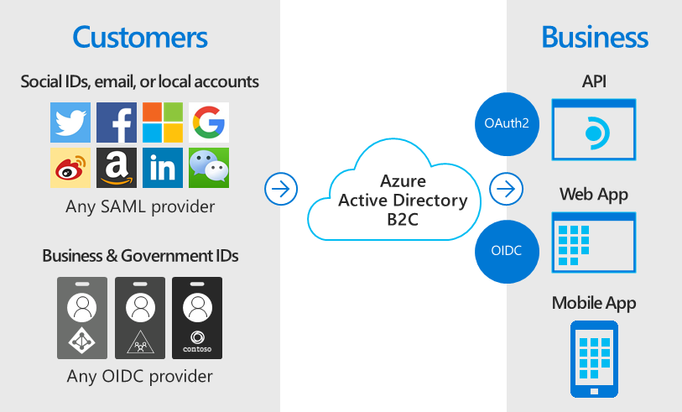

**Appendix B: Sample Login Page using Azure AD B2C**

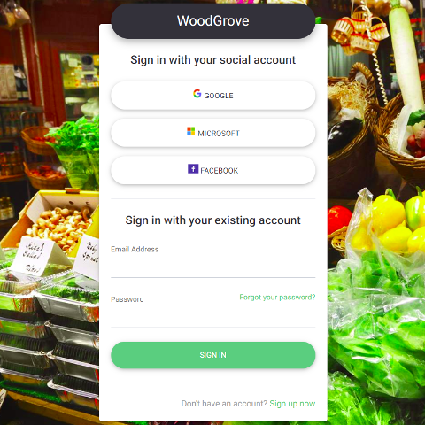

**Appendix C: VNet Integration**

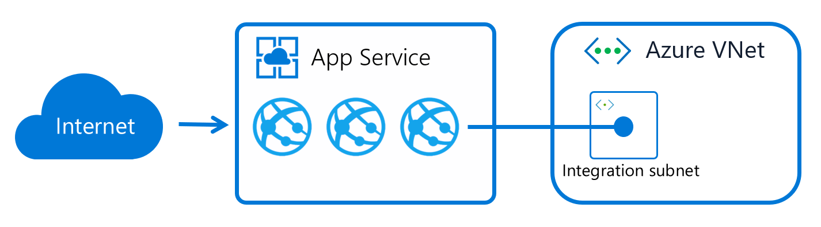

References

<https://www.panaton.com/post/13-risks-and-challenges-when-adopting-cloud-computing>

<https://www.watserv.com/blog/the-8-biggest-barriers-to-cloud-adoption/>

<https://www.watserv.com/blog/the-8-biggest-barriers-to-cloud-adoption/>

<https://learn.microsoft.com/en-us/azure/cloud-adoption-framework/innovate/considerations/challenges>

<https://insights.sei.cmu.edu/blog/12-risks-threats-vulnerabilities-in-moving-to-the-cloud/>

<https://learn.microsoft.com/en-us/azure/cloud-adoption-framework/govern/policy-compliance/risk-tolerance>

<https://www.pwc.com/m1/en/publications/five-challenges-cloud-adoption-how-overcome-them.html>

<https://www.cloudzero.com/blog/capex-vs-opex>

<https://azure.microsoft.com/en-us/blog/preparing-for-what-s-next-financial-considerations-for-cloud-migration/>

<https://www.linkedin.com/pulse/quick-how-to-cloud-corporate-management-how-eat-elephant-payette>

<https://stefanini.com/en/insights/articles/how-to-calculate-cloud-migration-cost-factors-to-consider>

<https://www.enavate.com/blog/cost-of-a-cloud-migration-vs-staying-on-premises-which-is-better>

<https://learn.microsoft.com/en-us/azure/cloud-adoption-framework/strategy/cloud-migration-business-case>

<https://www.tierpoint.com/blog/capex-vs-opex-cloud-whats-the-difference/>

<https://blog.clearscale.com/calculating-cloud-migration-costs/>

<https://www.itconvergence.com/blog/six-elements-to-calculate-the-cost-of-cloud-migration-project-estimate/>

<https://www.itconvergence.com/blog/12-cost-considerations-while-moving-data-center-to-cloud/>

<https://www.apptio.com/blog/5-reasons-cloud-migration-tco-analyses-fail/>

<https://aws.amazon.com/blogs/publicsector/cloud-economics-value-tco-assessment/>

<https://www.geeksforgeeks.org/capex-vs-opex-in-cloud-computing/>

<https://www.archive360.com/blog/revisited-capex-versus-opex-on-premises-versus-the-cloud>